Guru99 C#

1. Intro to C# How to print a simple string code.

using System;

namespace HelloWorld

{

class Program

{

static void Main(string[] args)

{

Console.WriteLine("Hello World!");

}

}

}

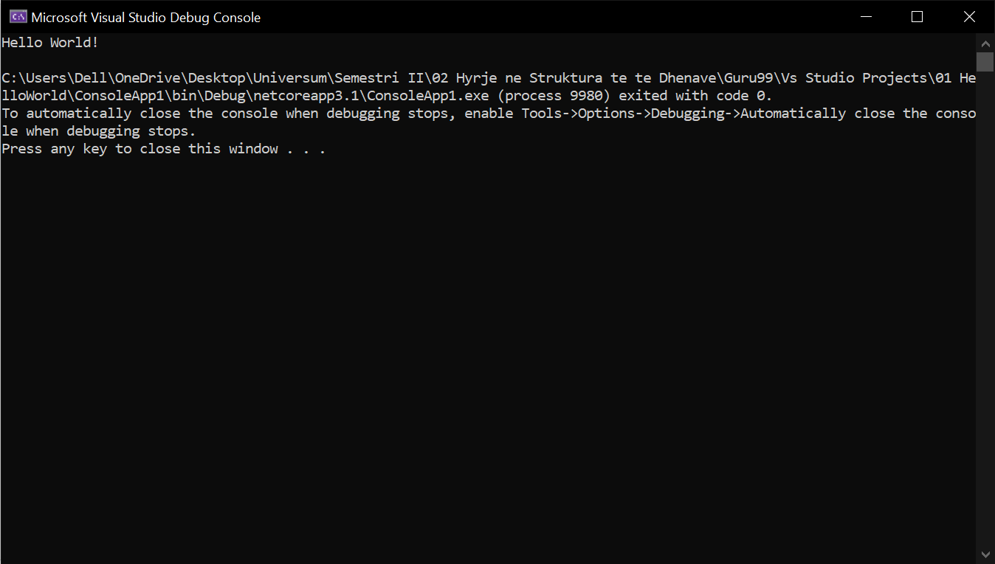

1. Printing a simple integer variable.

using System;

namespace Integer

{

class Program

{

static void Main(string[] args)

{

int num = 200;//integer variable

Console.Write(num);

}

}

}

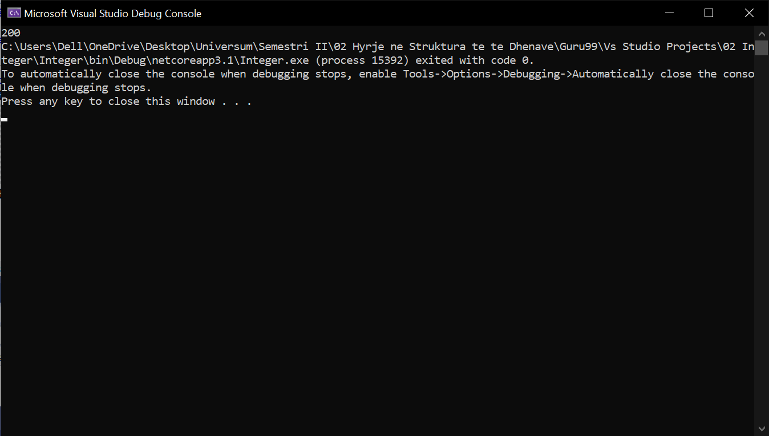

1. Printing a double variable

using System;

namespace Double

{

class Program

{

static void Main(string[] args)

{

double num = 50.55;//double variable

Console.WriteLine(num);

}

}

}

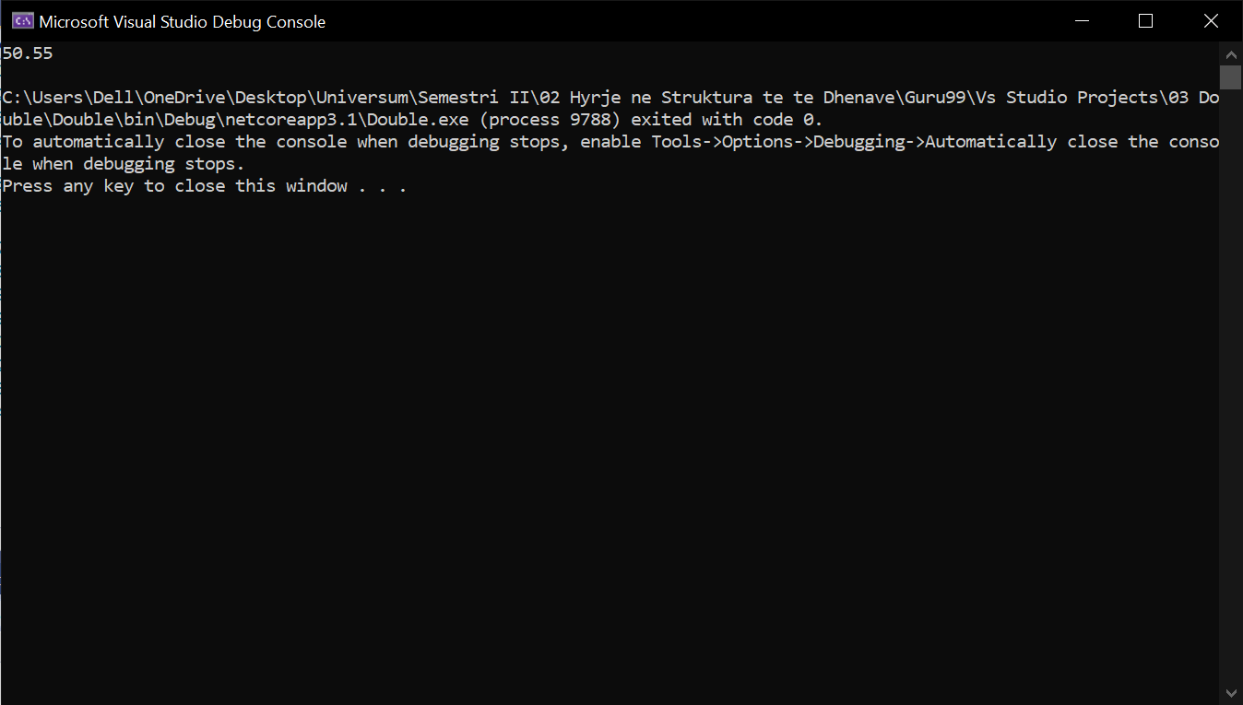

1. Printing a Boolean variable

using System;

namespace Boolean

{

class Program

{

static void Main(string[] args)

{

bool state = true;

Console.WriteLine(state);

}

}

}

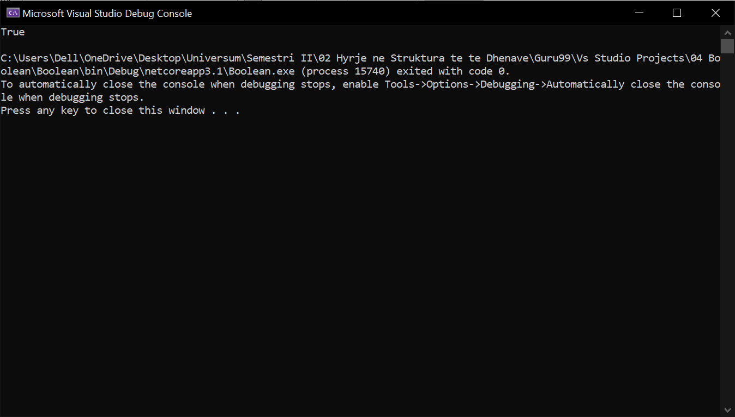

1. Printing a string variable

using System;

namespace String

{

class Program

{

static void Main(string[] args)

{

string meassage = "Bruh";

Console.WriteLine(message);

}

}

}

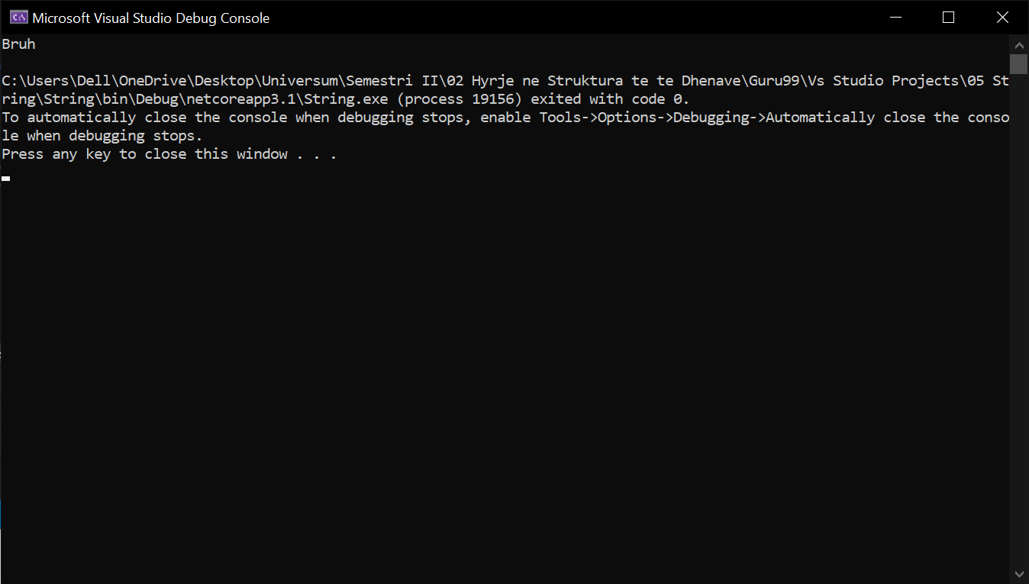

1. Printing a enum

using System;

namespace enum

{

class Program

{

enum Favmonths{january, february, march, april, may, june, july};

static void Main(string[] args)

{

Console.Write(Favmonths.january);

}

}

}

1. Printing two different variables into one Console.Write

using System;

namespace messageVaraiables

{

class Program

{

static void Main(string[] args)

{

string message = "Your number is: ";

int num = 4;

Console.Write(message + num);

}

}

}

1. Printing and using adding and the greater or less then methods also using Boolean variables and changing the status of it from true to false.

using System;

namespace _08_StringAndInt

{

class Program

{

static void Main(string[] args)

{

Int32 val1 = 100, val2 = 200;

bool status = true;

Console.WriteLine(val1 + val2);

Console.WriteLine(val1 < val2);

Console.WriteLine(!(status));

}

}

}

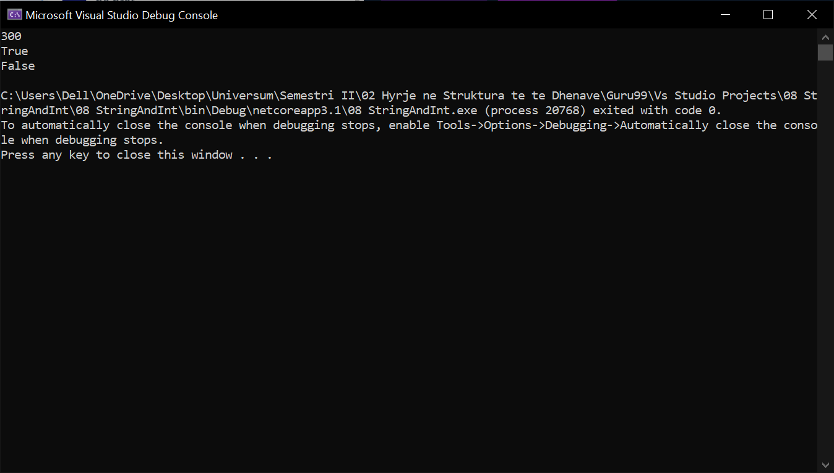

1. Using if statements to print something from looking at it if its greater or not

using System;

namespace _09_IfStatement

{

class Program

{

static void Main(string[] args)

{

int num1 = 9;

if(num1 < 7)

{

Console.WriteLine("Value is greater than 9");

}

else

{

Console.WriteLine("Value is less than 9");

}

}

}

}

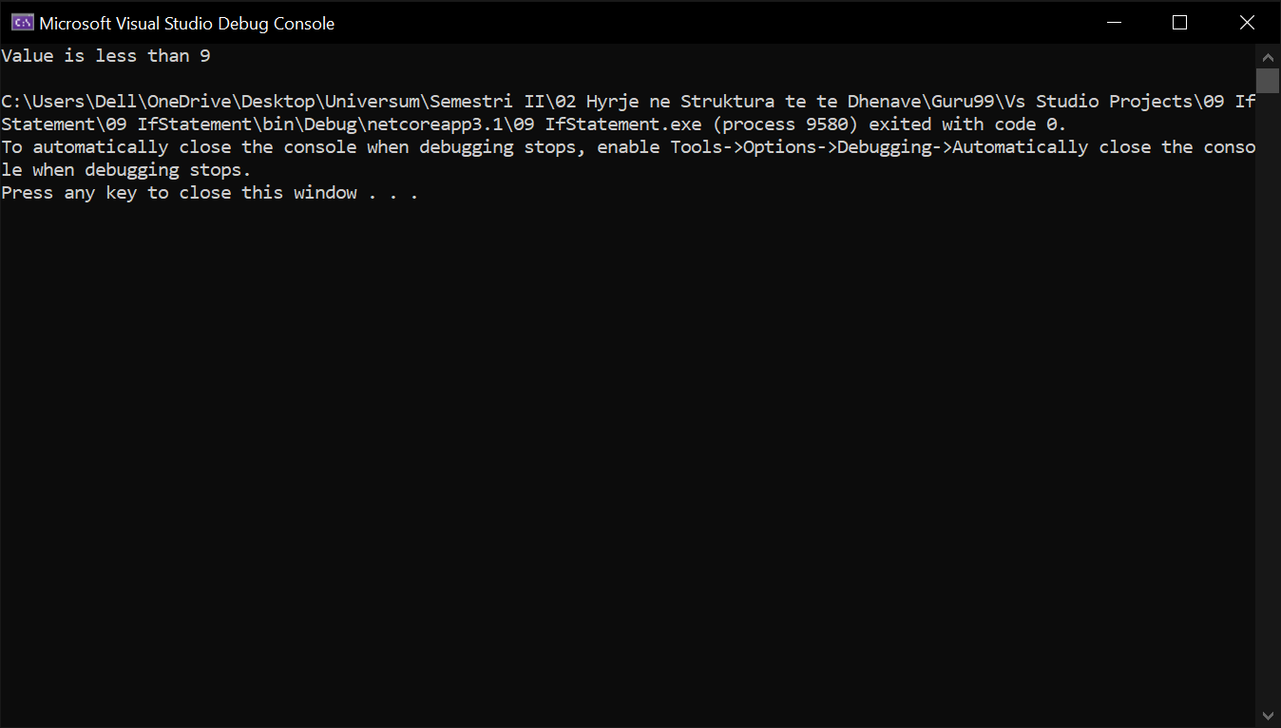

1. Switch statements

using System;

namespace _10_SwitchStatement

{

class Program

{

static void Main(string[] args)

{

int value = 12;

switch (value)

{

case 1:

Console.WriteLine("Value is 1");

break;

case 2:

Console.WriteLine("Value is 2");

break;

default:

Console.WriteLine("value is different");

break;

}

}

}

}

1. While statements

using System;

namespace WhileStatement

{

class Program

{

static void Main(string[] args)

{

Int32 value = 9, i = 0;

while (i < value)

{

Console.WriteLine(i);

i += 1;

}

}

}

}

1. For statement

using System;

namespace ForStatement

{

class Program

{

static void Main(string[] args)

{

for (Int32 i = 0; i < 5; i++)

{

Console.WriteLine(i);

}

}

}

}

1. Declearing array

using System;

namespace _13_DeclareingArray

{

class Program

{

static void Main(string[] args)

{

Int32[] value;

value = new Int32[4];

value[0] = 1;

value[1] = 2;

value[2] = 3;

value[3] = 4;

Console.WriteLine(value[0]);

Console.WriteLine(value[1]);

Console.WriteLine(value[2]);

Console.WriteLine(value[3]);

}

}

}

1. Using Stack

using System;

using System.Collections;

namespace usingStack

{

class Program

{

static void Main(string[] args)

{

Stack st = new Stack();

st.Push(1);

st.Push(2);

st.Push(3);

foreach (Object obj in st)

{

Console.WriteLine(obj);

}

Console.WriteLine(); Console.WriteLine();

Console.WriteLine("The number of elements in the stack " + st.Count);

Console.WriteLine("Does the stack contain the elements 3 " + st.Contains(3));

}

}

}

1. STACK

using System;

using System.Collections;

namespace _15_popingStack

{

class Program

{

static void Main(string[] args)

{

Stack st = new Stack();

st.Push(1);

st.Push(2);

st.Push(3);

st.Pop();

foreach (Object obj in st)

{

Console.WriteLine(obj);

}

}

}

}

1. CREATING QUE

using System;

using System.Collections;

namespace _16_creatingQue

{

class Program

{

static void Main(string[] args)

{

Queue qt = new Queue();

qt.Enqueue(1);

qt.Enqueue(2);

qt.Enqueue(3);

foreach (Object obj in qt)

{

Console.WriteLine(obj);

}

Console.WriteLine(); Console.WriteLine();

Console.WriteLine("The number of elements in the Queue " + qt.Count);

Console.WriteLine("Does the Queue contain " + qt.Contains(3));

}

}

}

1. REMOVING QUE

using System;

using System.Collections;

namespace _17_removingQue

{

class Program

{

static void Main(string[] args)

{

Queue qt = new Queue();

qt.Enqueue(1);

qt.Enqueue(2);

qt.Enqueue(3);

qt.Dequeue();

foreach (Object obj in qt)

{

Console.WriteLine(obj);

}

}

}

}

1. Hashtagable

using System;

namespace DemoApplication

{

class Program

{

static void Main(string[] args)

{

Hashtable ht = new Hashtable();

ht.Add("001",".Net");

ht.Add("002","C#");

ht.Add("003","ASP.Net");

ICollection keys = ht.Keys;

foreach (String k in keys)

{

Console.WriteLine(ht[k]);

}

Console.ReadKey();

}

}

}

1. Let's change the code in our Console application to showcase how we can use the "Containskey" and "ContainsValue" method.

using System;

namespace DemoApplication

{

class Program

{

static void Main(string[] args)

{

Hashtable ht = new Hashtable();

ht.Add("001",".Net");

ht.Add("002","C#");

ht.Add("003","ASP.Net");

Console.WriteLine(ht.ContainsKey("001"));

Console.WriteLine(ht.ContainsValue("C#"));

Console.ReadKey();

}

}

}